**Intellectual property rights**

**What is intellectual property?**

• Intellectual Property (IP) refers to creations of the mind that are unique and legally owned by an individual or organization.

• Examples include:

* **Books**
* **Films**
* **Formulas**
* **Inventions**
* **Music**
* **Business Processes**

• IP can be protected under various legal frameworks:

* **Copyright Law**: Protects original authored works (e.g., literature, music, art).
* **Patent Law**: Protects new inventions or discoveries, granting the inventor exclusive rights.
* **Trade Secret Law**: Safeguards confidential business information, ensuring competitive advantage.

**Legal Framework and Ethical Considerations**

* Copyright, patent, and trade secret laws collectively create a complex body of law governing the ownership and use of intellectual property.
* **Ethical Challenges**:
  + These laws can sometimes stifle creativity by restricting how innovations are shared and built upon.
  + Inventors and creators often seek compensation and control over their works, but this may conflict with the broader public interest in fostering innovation and access to knowledge.
* **Ethical Dilemma**:
  + Should the need for **innovation and knowledge sharing** take precedence over the rights of **property owners** to control their IP?
  + Balancing the rewards for creators with society’s need for ongoing innovation is a key issue in IP law.

**Challenges in Defining and Protecting IP in the Digital Age**

* Defining and controlling access to intellectual property has become increasingly complex, especially with digital content and software.
  + **Software as IP**:
    - Software can sometimes be viewed as an **expression** (protected under copyright law).
    - Alternatively, it may be seen as a **process or invention** (protected under patent law).
  + The line between copyrighted expressions and patent-protected processes is often blurred, creating additional challenges in IP protection.

**Copy Rights**

**Copyright Law and U.S. Constitution**

* Established in the **U.S. Constitution**:
  + **Article I, Section 8, Clause 8** grants creators of original works the exclusive right to:
    - **Distribute**
    - **Display**
    - **Perform**
    - **Reproduce** the work
    - **Prepare derivative works** based upon the original work
* The author can also **grant exclusive rights to others** (e.g., through licensing agreements).

• Copyright protection is granted to the creators of:

“Original works of authorship in any tangible medium of expression, now known or later developed, from which they can be perceived, reproduced, or otherwise communicated, either directly or with the aid of a machine or device.”

* **Example**: An author writes a book that can be read directly in print form or through a digital device like an e-reader. This work is protected by copyright law.

• The author may grant this exclusive right to others (e.g., a publishing company to distribute the book).

When an author writes a book, **copyright law** automatically protects the book. This means the author has the exclusive right to:

* **Distribute** the book (e.g., sell it in stores).
* **Reproduce** the book (e.g., make copies of it).
* **Display** or **perform** the book publicly (e.g., reading it aloud in public).
* Create **derivative works** (e.g., make a movie based on the book).

Now, the author can choose to keep all these rights or **grant** (or **license**) these rights to other people or companies. For example, the author might:

* Give a **publishing company** the right to **distribute** the book, meaning the publisher can print and sell the book in stores.
* Give an **e-book company** the right to sell the book on **digital devices** like e-readers.

Even though the publisher or e-book company has the rights to sell or distribute the book, the author still owns the copyright.

Here’s an expanded version of your content with the definition of piracy added:

**Copyright Infringement**

* **Copyright infringement** is a violation of the rights secured by the owner of a copyright.
  + Infringement occurs when someone **copies** a substantial and material part of another’s copyrighted work without permission.
* **Piracy** is a form of copyright infringement where the unauthorized reproduction and distribution of copyrighted materials (such as movies, music, software, or books) are done on a large scale, often for commercial gain.

Example: If someone makes illegal copies of a movie and sells them without the filmmaker's permission, that would be considered piracy.

**Copyright Term**

* **Copyright law** guarantees developers (authors, creators) exclusive rights to their works for a certain period of time.

The **Sonny Bono Copyright Term Extension Act** extends the duration of copyright protection in the United States. Here's what it conveys:

1. **For works created on or after January 1, 1978**:
   * Copyright protection lasts for the **life of the author plus 70 years**. This means the author holds exclusive rights during their lifetime, and after their death, those rights are extended for an additional 70 years. This allows heirs or estates to continue benefiting from the work.
2. **For works created before January 1, 1978 but not published or registered**:
   * These works are also protected for the **life of the author plus 70 years**. However, there is a rule that the copyright cannot expire before **December 31, 2004**. This ensures older, unpublished works don’t fall into the public domain prematurely.
3. **For works created before 1978 that are still under their original or renewable copyright term**:
   * The copyright is extended to last for **95 years** from the date the copyright was originally secured. This gives longer protection to older works that were copyrighted before the 1978 changes in copyright law.

This extension provides authors and their families with longer control over their intellectual property, allowing for greater financial benefit from the work over a longer period of time.

**Types of Work That Can Be Copyrighted**

Copyright law protects a wide range of creative works, including:

* **Architecture**
* **Art**
* **Audiovisual works**
* **Choreography**
* **Drama**
* **Graphics**
* **Literature**
* **Motion pictures**
* **Music**
* **Pictures**
* **Sculptures**
* **Sound recordings**
* **Other intellectual works**: As described in Title 17 of the U.S. Code

**Note**: Copyright laws are flexible and extend to new technologies, including:

* **Software**
* **Games**
* **Multimedia**
* **Web pages**

**Eligibility for Copyright Protection**

To qualify for copyright, a work must:

1. **Fall within a specified category** (e.g., literature, art, music).
2. **Be original**: Must display a minimal degree of creativity.

**Works Not Eligible for Copyright**

* **Not fixed in tangible form**: Ideas or concepts not expressed physically.
* **Common terms or phrases**: Lacks originality and may be protected by trademark law.
* **No original authorship**: Purely factual works without creative expression.

**Fair Use Doctrine**

The **Fair Use Doctrine** allows limited portions of copyrighted materials to be used without permission under certain circumstances. It seeks to balance protecting an author’s rights with enabling public access to copyrighted works.

**Factors to Consider for Fair Use**

When evaluating the use of copyrighted material, consider the following factors:

1. **Purpose and character of the use**: Is it for commercial or educational purposes? Transformative uses (e.g., commentary, criticism) may favor fair use.
2. **Nature of the copyrighted work**: Creative works may have less fair use protection than factual works.
3. **Portion of the copyrighted work used**: Using a smaller, less significant portion of the work generally favors fair use.
4. **Effect of the use upon the value of the copyrighted work**: If the use negatively impacts the market value of the original work, it may weigh against fair use.

**Key Concept**

* An **idea** cannot be copyrighted, but the **expression of an idea** can be.
* There is **no copyright infringement** if two parties independently develop similar works.

**Copyrights (Continued)**

**The PRO-IP Act of 2008**

* **Purpose**: Strengthened enforcement of intellectual property rights.
* **Key Features**:
  + Increased penalties for copyright infringement.

**General Agreement on Tariffs and Trade (GATT)**

* **Overview**: A trade agreement among 117 countries.
* **Impact**: Led to the creation of the **World Trade Organization (WTO)**.
* **Variation in Protection**: Despite GATT, copyright protection varies significantly between countries.

**WTO and the TRIPS Agreement (1994)**

* **Recognition**: Acknowledges the growing importance of intellectual property in global trade.
* **Minimum Protection Levels**: Establishes baseline protections for intellectual property that member governments must provide.
* **Coverage**: Includes copyrights, patents, and trade secrets.
* **World Trade Organization (WTO)**
* The World Trade Organization (WTO) is an international organization that regulates trade between nations to ensure smooth and predictable trade flows. Established through the General Agreement on Tariffs and Trade (GATT), the WTO aims to promote free trade and resolve trade disputes among its member countries.
* **TRIPS Agreement**
* The TRIPS Agreement (Trade-Related Aspects of Intellectual Property Rights) is a treaty under the WTO that sets minimum standards for intellectual property protection, including copyrights, patents, and trade secrets. It aims to harmonize IP laws across member countries, recognizing the critical role of intellectual property in global trade and economic development

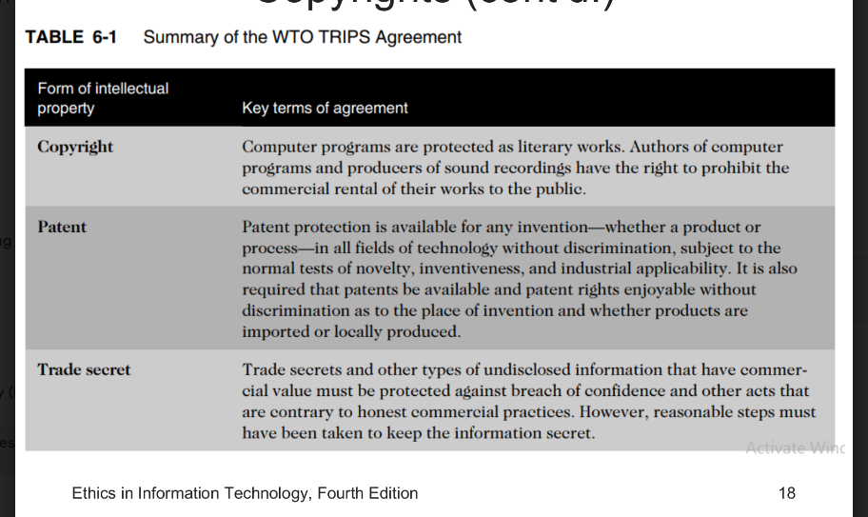

**World Intellectual Property Organization (WIPO)**

The World Intellectual Property Organization (WIPO) is a specialized agency of the United Nations that advocates for the rights and interests of intellectual property owners globally.

The WIPO Copyright Treaty enhances copyright protections specifically for electronic media, addressing the challenges posed by digital technologies.

**Digital Millennium Copyright Act (DMCA)**

The **Digital Millennium Copyright Act (DMCA)** is the U.S. implementation of the WIPO treaty, aimed at protecting copyrighted material in the digital environment.

**Key Features:**

* **Civil and Criminal Penalties**: The DMCA imposes penalties for copyright infringement, both civil and criminal.
* **Regulation of Circumvention Tools**: It governs the distribution of tools and software designed to circumvent technological measures that protect copyrighted works.
* **Safe Harbors for ISPs**: Internet Service Providers (ISPs) are provided safe harbors from liability if they comply with “notice and takedown procedures,” allowing copyright holders to request the removal of infringing content.

**New Provisions Under the DMCA:**

The DMCA makes it an offense to:

* **Circumvent Technical Protections**: Bypassing digital rights management (DRM) or other protective measures is illegal.
* **Develop and Provide Circumvention Tools**: Creating tools that allow access to protected works without authorization is prohibited.
* **Manufacture or Traffic in Circumvention Tools**: Producing, importing, or distributing tools that enable the circumvention of copyright protection is also illegal.

**Example:**

For instance, if a software developer creates an application that allows users to bypass the DRM of a music streaming service to download songs for free, this action would violate the DMCA. The developer could face legal repercussions for circumventing the technical protections that the service has in place.

**Example of DMCA in Action:**

Several legal cases under the DMCA have focused on the use of software related to the copying of DVDs. For instance, the **Content Scramble System (CSS)** is a technology used to protect DVDs from unauthorized copying. However, a software program called **DeCSS** was developed to break this encryption and allow users to copy DVDs. In 2000, the distribution of DeCSS led to a lawsuit by major movie studios, which resulted in courts ruling that using DeCSS violated the DMCA’s anticircumvention provisions.

**Key Points:**

* **Power to Copyright Holders**: Critics argue that the DMCA allows copyright holders to exert excessive control, potentially limiting access to information.
* **ISPs Responsibilities**: Under the DMCA, Internet Service Providers (ISPs) are required to remove access to websites that are accused of copyright infringement, even if the infringement hasn’t been proven. This can lead to wrongful takedowns of legitimate content.
* **Legal Risks for Companies**: Companies that provide access to music and video content face legal action if they do not secure the necessary permissions to distribute content from the music and movie industries, which can threaten their business viability

**Patents**

1. **Definition of Patents**:
   * Patents grant property rights to inventors, protecting their inventions from unauthorized use.
   * **Issuing Authority**: Patents are issued by the U.S. Patent and Trademark Office (USPTO).
2. **Rights Granted**:
   * A patent permits the owner to exclude the public from making, using, or selling the protected invention for a certain period.
   * **Legal Protections**: Patent holders can take legal action against individuals or companies that violate their patent rights, ensuring that their innovations are protected from both copying and independent creation.
3. **Geographical Limitations**:
   * Patent protection extends only to the United States and its territories and possessions, meaning that a patent granted in the U.S. does not provide rights in other countries.

**Patent Application Process**

1. **Filing Process**:
   * An applicant must file a patent application with the USPTO, detailing their invention.
   * **Prior Art Search**: The USPTO conducts a search of prior art, which refers to the existing body of knowledge relevant to the invention, to assess whether the invention is novel and non-obvious.
2. **Processing Time**:
   * On average, it takes about **35.3 months** from filing an application until it is either issued as a patent or abandoned, reflecting the complexity of the examination process.

**Criteria for Patentability**

1. **Tests for Invention**:
   * An invention must pass four tests to be eligible for a patent:
     + **Statutory Class**: It must belong to one of the five statutory classes of items (process, machine, manufacture, composition of matter, or improvement thereof).
     + **Usefulness**: The invention must be useful, meaning it has a specific and practical utility.
     + **Novelty**: The invention must be novel, indicating that it is new and has not been previously disclosed or known.
     + **Non-obviousness**: It must not be obvious to a person having ordinary skill in the relevant field, ensuring that the invention represents a sufficient technological advancement.
2. **Items That Cannot Be Patented**:
   * Certain items cannot be patented, including:
     + **Abstract Ideas**: Ideas that lack a concrete application or implementation.
     + **Laws of Nature**: Natural laws that cannot be owned or patented.
     + **Natural Phenomena**: Naturally occurring elements or occurrences that are not created or significantly altered by humans.

**Patent Infringement Overview**

1. **Definition**:
   * Unauthorized use of another’s patented invention.
2. **Financial Penalties**:
   * No specified limit on monetary penalties for infringement.
3. **Common Defense**:
   * Accused parties often counterattack, challenging the validity of the patent.
4. **Burden of Proof**:
   * The patent holder must prove every element of the infringement claim.
5. **Financial Loss**:
   * The patent holder must show that the infringement resulted in financial loss.

**Software Patents Overview**

**Definition**:

* Protects features, functions, or processes executed by computer instructions.

**Volume of Patents**:

* Approximately **20,000 software-related patents** are issued annually since the early 1980s.

**Concerns**:

* Some experts argue that the large number of software patents may inhibit new software development.

**Historical Context**

**Pre-1981**:

* Courts regularly rejected software patent requests, implying software could not be patented.

**Key Case - Diamond v. Diehr (1981)**:

* The Supreme Court granted a patent for a process control computer developed by Diehr, which monitored temperature in rubber molding.
* This decision clarified that using software does not disqualify an invention from being patented.

**Types of Software Patents**

* **Categories**:
  + Applications software
  + Business software
  + Expert systems
  + System software
* **Processes Patented**:
  + Compilation routines
  + Editing and control functions
  + Operating system techniques
  + Electronic font types and icons

**Software Patents**

* **Patent Search:** Before applying for a software patent, it's essential to conduct a patent search.
* **Database:** The Software Patent Institute is creating a database to help with this.
* **Concerns:** An excess of software patents can hinder new software development.

**Example Case**

* **Amazon vs. Barnes & Noble:** In October 1999, Amazon.com sued Barnes & Noble for allegedly infringing its patent with the "Express Lane" feature.
* **Criticism of Business Method Patents:** The lawsuit raised concerns about patents for business methods, which critics believe are too broad and not original enough to warrant patents.
* **One-Click Shopping:** Critics argued that Amazon's one-click shopping was simply a combination of existing web technologies.
* **Settlement:** After initial court hearings and evidence that others had used similar technology before Amazon, the two companies settled out of court in March 2002.

**Challenges for Software Engineers**

* **Patent Database Searches:** Software engineers often do not search patent databases for new inventions that could enhance their projects.
  + **Obscure Language:** Software patents are often written in complex and obscure language, making them difficult to understand.
  + **Risk of Infringement:** Engineers face the risk of paying triple damages if they knowingly infringe on a patent.

**Example Case: Cygnus Systems**

* **Allegations:** In late 2008, Cygnus Systems claimed that Apple, Google, and Microsoft infringed a patent it filed in 2001.
* **Patent Details:** Cygnus alleges that the patent covers the use of document-preview icons (thumbnails).
* **Affected Products:** The technology is said to be used in:
  + Apple’s iPhone, Safari browser, and Mac OS X Leopard
  + Google’s Chrome browser
  + Microsoft’s Vista OS and Internet Explorer 8
* **Implications:** Due to the common use of this technology, many more companies could potentially face lawsuits for patent infringement.

**Software Cross-Licensing Agreements**

* **Definition:** Large software companies enter agreements to refrain from suing each other over patent infringements.
* **Example:**
  + **Microsoft's Strategy:** In 2010, Microsoft aimed to establish over 100 cross-licensing agreements with firms like IBM.
  + **Benefits for Microsoft:** This approach allows Microsoft to obtain rights to technologies that could be used in its products, offering significant development freedom without the threat of costly litigation.
* **Impact on Small Businesses:**
  + Small businesses lack the leverage of large companies and must license patents if they intend to use them, which can be a financial burden

**Defensive Publishing**

* **Definition:** An alternative to filing for patents.
* **Process:**
  + Companies publish a detailed description of their innovation.
  + This action establishes the idea's legal existence as **prior art**, which can prevent others from patenting the same idea.
* **Benefits:**
  + **Cost-effective:** Only requires a few hundred dollars.
  + **No legal fees:** Does not involve lawyers.
  + **Speed:** The process is quicker than obtaining a patent.

**Patent Troll Firms**

* **Definition:** Companies that acquire patents solely for the purpose of licensing them, not for manufacturing products.
* **Example:**
  + **Intellectual Ventures:**
    - Holds a portfolio of over 20,000 patents, primarily in IT-related technology.
    - Major IT firms, including Google, Intel, eBay, NVIDIA, SAP, Sony, Microsoft, and Nokia, have invested in Intellectual Ventures to obtain licenses to its patents.
* **Impact on Industry:**
  + Some IT organizations pay substantial sums for the right to use one or more patents from such firms.

**Standards in Technology**

* **Definition:** A standard is a defined specification or format.
* **Approval:**
  + Recognized by standards organizations (e.g., ISO, IEEE).
  + Can be a de facto standard widely accepted in the industry.
* **Purpose:** Ensures compatibility and interoperability among hardware and software from different manufacturers.

**Submarine Patents**

* **Definition:** A submarine patent is a patented process or invention that is hidden within a standard.
* **Application Areas:**
  + Communication protocols
  + Programming languages
  + Operating systems
  + Data formats
  + Electrical interfaces
* **Significance:** Standards facilitate interoperability, allowing hardware and software from different manufacturers to work together.
* **Visibility:** The patent remains undisclosed until the standard is widely adopted.

**Patent Farming**

* **Definition:** Patent farming involves:
  + **Influencing Standards Organizations:** Encouraging organizations to adopt patented items without disclosing the patent's existence.
  + **Demanding Royalties:** Seeking royalties from all parties that utilize the standard.

**Example of Patent Farming**

* **U.S. Patent 5,838,906:**
  + **Ownership:** Owned by the University of California, exclusively licensed to Eolas Technologies.
  + **Description:** The patent details how a web browser can utilize external applications.
  + **Initial Secrecy:** The University of California did not disclose the patent for years and subsequently sued Microsoft for infringing on the patented principle.

**Legal Outcomes**

* **Settlement:** In August 2003, a federal jury awarded the University of California and Eolas $520 million after finding that Microsoft's Internet Explorer infringed the patent.
* **Review Request:** In November 2003, Tim Berners-Lee, creator of the World Wide Web, requested a review of the patent, arguing it should be invalidated due to prior art.
* **Court Decision:** In January 2004, a federal judge upheld the initial ruling, confirming that Microsoft must pay the $520 million.

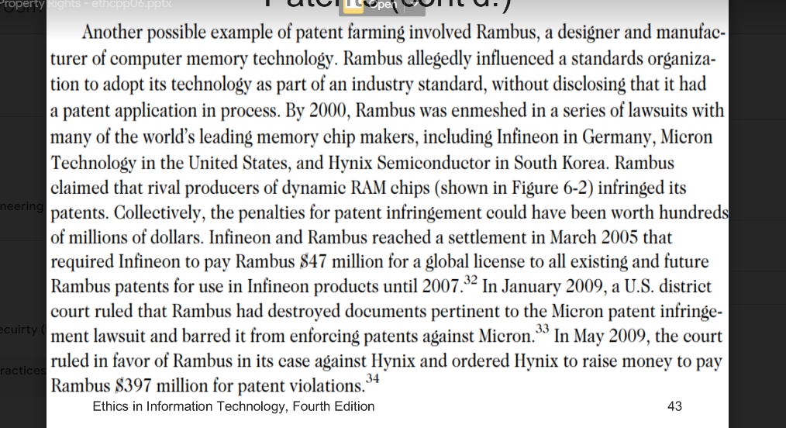

Tradeoff

**Trade Secrets**

* **Definition:**
  + **Business Information:** Represents valuable information that is not publicly known.
  + **Economic Value:** Has economic worth due to its confidentiality.
  + **Development Effort:** Requires effort or cost to create.
  + **Uniqueness:** Possesses a degree of uniqueness or novelty.
  + **Confidentiality:** Must be kept confidential; protected by the company's efforts.
* **Key Characteristics:**
  + Information is only considered a trade secret if the company actively takes steps to protect it.

**Advantages of Trade Secret Law**

1. **No Time Limitations:** Unlike patents, trade secrets do not expire as long as they remain confidential.
2. **No Application Process:** No need to file an application to establish protection.
3. **Court Invalidations:** Patents can be declared invalid by courts, but trade secrets are not subject to this.
4. **No Fees:** No filing or application fees are required.
5. **Independent Development:** The law does not prevent others from using the same idea if they develop it independently.

* **Variability:** Trade secret laws differ significantly from country to country.

**Key Trade Secret Laws**

1. **Uniform Trade Secrets Act (UTSA):**
   * Aims to create consistency in trade secret law across states.
   * Protects both computer hardware and software as trade secrets.
2. **Economic Espionage Act (EEA) of 1996:**
   * Imposes penalties of up to $10 million and up to 15 years in prison for the theft of trade secrets.

**Employee Risks to Trade Secrets**

* **Greatest Threat:**
  + Employees can unintentionally or intentionally compromise trade secrets.
* **Unauthorized Use:**
  + Employees may misuse or share an employer’s customer list without permission.
  + A customer list is not automatically considered a trade secret; it must meet specific criteria to qualify for protection.

**Mitigation Strategies**

1. **Employee Education:**
   * Educate employees about the importance of confidentiality regarding sensitive information, including customer lists.
2. **Nondisclosure Clauses:**
   * Include nondisclosure agreements (NDAs) in employee contracts to legally bind them to confidentiality.
3. **Enforcement Challenges:**
   * Enforcing confidentiality agreements can be challenging, especially if a breach occurs.
4. **Exit Interviews:**
   * Review confidentiality issues during exit interviews to reinforce the importance of protecting trade secrets even after employment ends.

**Nondisclosure Agreements (NDAs)**

* **Challenge in Definition:**
  + Defining reasonable nondisclosure agreements can be complex, as demonstrated by Apple's approach.
* **Apple's Restrictive NDA:**
  + Apple implemented a restrictive NDA for iPhone developers to protect its technology.
  + Developers faced strict limitations, including:
    - Prohibition on discussing their coding work with anyone outside the project team.
    - Restrictions on talking about the NDA terms themselves.
  + **Outcome:**
    - Due to widespread complaints from developers about the overly restrictive terms, Apple later relaxed the NDA for software that had already been released.

**Employees and Trade Secrets**

* **Ohio State Supreme Court Ruling:**
  + A significant ruling upheld a verdict against an employee who left a financial services firm and recruited former clients for his new business.
  + Key points from the case:
    - The former employee did not steal a client list.
    - The court ruled that confidential client information could qualify as a trade secret, regardless of whether it was documented or retained in memory.
  + **Implication:**
    - This ruling underscores the protection of trade secrets and the legal consequences for employees who use confidential information without authorization.

**Noncompete Agreements**

**Purpose**

* **Protection of Intellectual Property:**
  + Noncompete agreements are designed to prevent key employees from using proprietary knowledge and intellectual property to benefit competitors when they leave an organization.

**General Terms**

* **Typical Conditions:**
  + Employees agree not to work for competitors for a specified period (e.g., two years).
  + Restrictions may include:
    - Not engaging in similar or competitive businesses.
    - Not contacting or soliciting customers the employer worked with during the employee's tenure.
  + **Geographic Scope:**
    - Often includes a defined area (e.g., a 100-mile radius from the employer’s business location).

**Examples**

1. **IBM and Mark Papermaster Case:**
   * **Background:**
     + Mark Papermaster, a microchip expert, intended to leave IBM to join Apple as the head of device hardware engineering.
   * **Lawsuit:**
     + IBM sued Papermaster for violating his noncompete agreement.
   * **Settlement:**
     + The lawsuit was settled when Papermaster agreed to:
       - Report any potential breakthroughs at Apple that might infringe on IBM's proprietary information.
       - Submit written declarations to IBM stating he was not using any confidential materials from IBM in his new role at Apple.

**Issues That Apply to Intellectual Property and Information Technology**

1. Plagiarism
2. Reverse engineering
3. Open source code
4. Competitive intelligence
5. Trademark infringement
6. Cybersquatting

**Plagiarism Overview**

* **Definition**: Stealing someone’s ideas or words and passing them off as one’s own.
* **Common Misunderstandings**:
  + Many students do not understand what constitutes plagiarism.
  + Some believe that all electronic content is in the public domain.
* **Prevalence**: Plagiarism is common outside of academia as well.
* **Detection**: Plagiarism detection systems check submitted material against databases of electronic content.

**Steps to Combat Student Plagiarism**

1. **Educate on Plagiarism**: Help students understand what constitutes plagiarism and the importance of citing sources.
2. **Document Web Sources**: Show students how to properly document web pages.
3. **Schedule Assignments**: Schedule major writing assignments in portions due throughout the term.
4. **Raise Awareness**: Inform students that instructors are aware of internet paper mills and plagiarism detection services.
5. **Incorporate Detection**: Integrate plagiarism detection into an anti-plagiarism program.

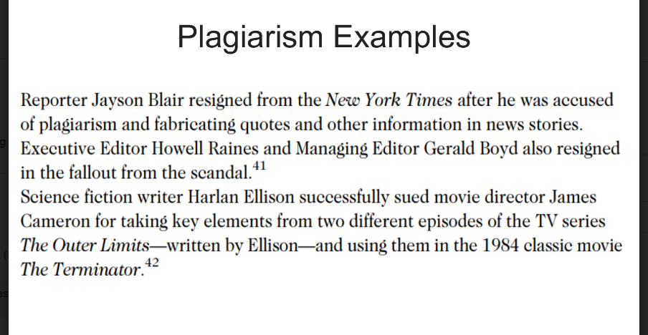

**Reverse Engineering**

* **Definition**: The process of taking something apart to understand it, build a copy, or improve it.
* **Applications**:
  + **Hardware**
  + **Software**: Converts program code to a higher-level design.
* **Example**: Converting an application from one vendor’s database to another’s.

**Key Points**

* **Reverse Engineering vs. Forward Engineering**:
* **Reverse Engineering** is the process of deconstructing a product to understand its design and functionality, while **Forward Engineering** involves creating a new system or product based on requirements and specifications.
  + **In-house**: Generally accepted and no ethical issues.
  + **External**: Considered unethical and may raise licensed, copyright, or patent issues.
* **Legality**:
  + Not illegal if it promotes interoperability.
  + Information that is not protected can be reverse engineered.

**Tools**

* **Compiler**:
  + A language translator that converts program statements from a source language to machine language.
* **Decompiler**:
  + Reads machine language and produces source code, potentially granting access to copyrighted information or trade secrets.

**Courts Have Ruled in Favor of Reverse Engineering:**

1. **To Enable Interoperability**
   * **Example:** *Sega Enterprises Ltd. v. Accolade, Inc.*: An appeals court ruled that if someone lacks access to unprotected elements of an original work and has a “legitimate reason” for gaining access, disassembly of a copyrighted work is considered fair use under Section 107 of the Copyright Act.
2. **To Restrict Manufacturer Monopoly**: Courts recognize that reverse engineering can promote competition by allowing access to necessary components for interoperability, reducing monopolistic practices.

**Reverse Engineering (cont’d.)**

* **Software License Agreements**: In the USA, many software license agreements explicitly forbid reverse engineering.
* **Ethics Debate**: The ethics of reverse engineering are debated, often considered fair use if it provides useful functionality or interoperability, especially when documentation is not provided.
* **Costly Designs**: Reverse engineering can uncover designs that others have developed at significant cost and taken care to protect.

**Open Source Code**

**Definition**: Program source code made available for use or modification as users or other developers see fit.

**Basic Premise**:

* Many programmers can collaborate to improve software.
* Code can be adapted to meet new needs.
* Bugs are rapidly identified and fixed, contributing to high reliability.

**Reasons Why Source Code is Created**

1. **Respect for Problem Solving**: Some individuals share code to earn respect for solving common problems elegantly.
2. **Paying It Forward**: Developers who have used open source code created by others may feel the need to contribute back to the community.
3. **Client Agreements**: A firm may be required to develop software as part of a contractual agreement. If they are paid for employee time rather than the software itself, they might license the code as open source to promote their expertise or attract potential clients with similar problems.
4. **Maintenance Fees**: Firms may develop open source code in hopes of earning maintenance fees if end users require future changes.
5. **Donation of Useful Code**: A firm may develop useful code but hesitate to license or market it, opting instead to donate it to the public.

**Legal Context**

* **GNU General Public License (GPL)**: A precursor to the Open Source Initiative (OSI) that has influenced open source licensing practices.

**Notable Case**

* **Bob Jacobsen vs. Matthew A. Katzer**: A significant case involving open source licensing, highlighting issues around the rights and obligations associated with open source software.

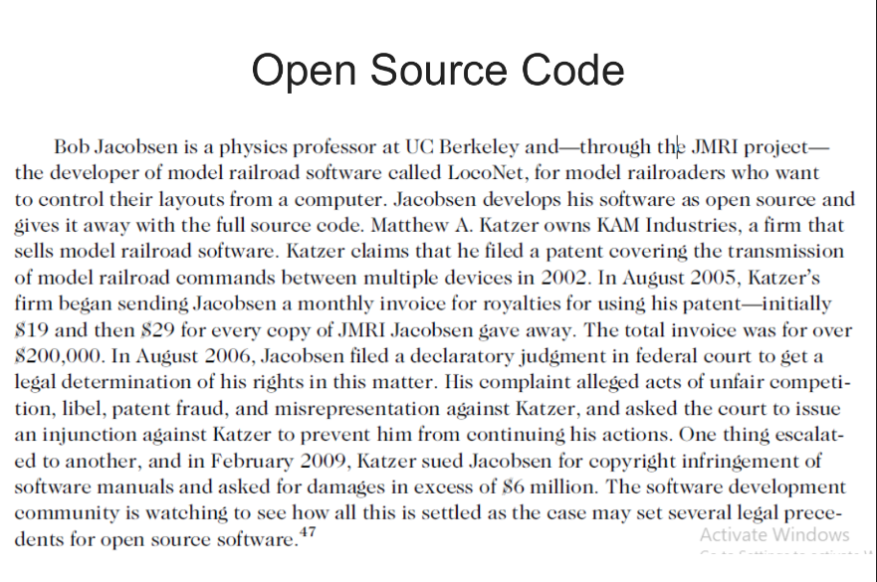

**Competitive Intelligence**

**Definition**: The gathering of legally obtainable information to help a company gain an advantage over its rivals.

**Key Points**:

* **Integration**: Competitive intelligence is often integrated into a company’s strategic plans and decision-making processes.
* **Legality**: It is not the same as industrial espionage, which involves illegal means to obtain business information not available to the public.
* **Caution**: Without proper management safeguards, competitive intelligence practices can unintentionally cross over into industrial espionage.

**Ethical Considerations**

* **Potential for Misconduct**: Without ethical oversight, competitive intelligence efforts may lead to unethical practices.
* **Common Tricks**: An example of an unethical method includes entering a bar near a competitor’s headquarters, engaging individuals in conversation, and attempting to extract information when their inhibitions are lowered due to alcohol.
* **Guidelines for Analysts**: Competitive intelligence analysts must avoid actions such as lying, misrepresentation, theft, bribery, or using illegal eavesdropping devices.
* The **P&G vs. Unilever case** exemplifies ethical dilemmas in competitive intelligence. **P&G** accused **Unilever** of hiring former P&G employees to access confidential information about its operations, raising concerns about the ethical boundaries of competitive practices.
* The case highlights the fine line between **legitimate competitive intelligence** and unethical actions that harm business interests. It also underscores how companies manage employees transitioning between firms and what information can be ethically retained.
* This case serves as a reminder for firms to establish clear guidelines to avoid crossing into industrial espionage.

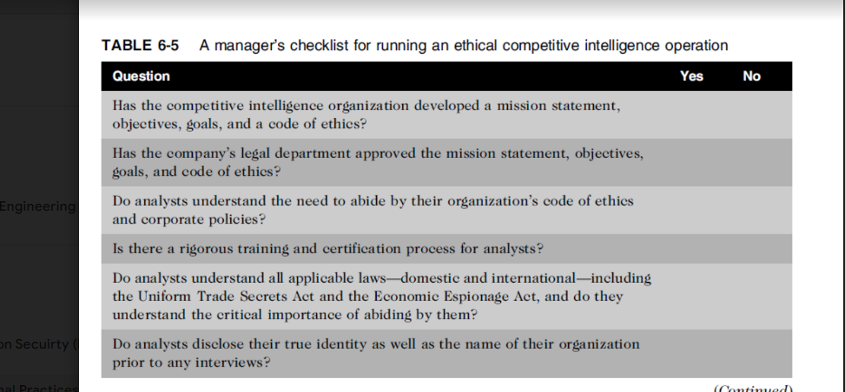

**Trademark Infringement**

* A **trademark** can be a logo, design, phrase, sound, or word that helps consumers distinguish a company's product from others.
* Trademark owners can prevent others from using the same or confusingly similar marks on products.
* Organizations often sue each other over trademark use in websites or domain names.
* **Nominative fair use** is a common defense in trademark infringement cases.

Top of Form

Bottom of Form

**Cybersquatters**

* Register domain names of famous trademarks or company names.
* Aim to sell the domain to the trademark owner for a high price.
* Companies can prevent cybersquatting by registering multiple domain variations (.org, .com, .info).

**Cybersquatting (cont’d)**

* The **Internet Corporation for Assigned Names and Numbers (ICANN)** oversees domain name management.
* Trademark holders get a chance to assert their rights before new top-level domains are publicly available.
* The **Anticybersquatting Consumer Protection Act** allows trademark owners to challenge foreign cybersquatters.

4o

**Cybersquatting (cont’d.)**

* **OnlineNIC** was one of the first domain registrars licensed by **ICANN**.
* In 2008, **Verizon Communications**, **Microsoft**, and **Yahoo!** filed lawsuits against OnlineNIC for registering domain names similar to their trademarks (e.g., *verizon-cellular.com*, *encarta.com*, *yahoozone.com*).
* In December 2008, **Verizon** was awarded **$31.15 million** in damages.
* OnlineNIC was banned from registering any domain names containing Verizon trademarks and was ordered to transfer the disputed domain names to Verizon.

**ntellectual property is protected by laws for:**

* **Copyrights**
* **Patents**
* **Trademarks**
* **Trade secrets**
* **Plagiarism**: Stealing and passing off the ideas and words of another as one’s own.
* **Reverse engineering**: Breaking something down to understand, build a copy of, or improve it.
* **Open source code**: Made available for use or modification as users or developers see fit.
* **Competitive intelligence**: Uses legal means and public information.
* **Trademark infringement**: Using someone else’s trademark on a website can cause legal issues.
* **Cybersquatting**: Registering a domain name by an unaffiliated party.